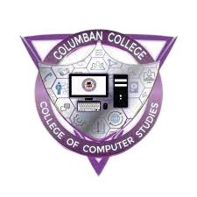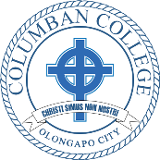

THIS CERTIFICATE IS PROUDLY PRESENTED TO

*For teaching Web Designing in Columban College I.T. summer training 2022*

Columban College Inc.

**Joseph Dela Cruz Jr.**

Surname

Date